~Asia-China-Mirror-Tang-Lion and Grapes-5

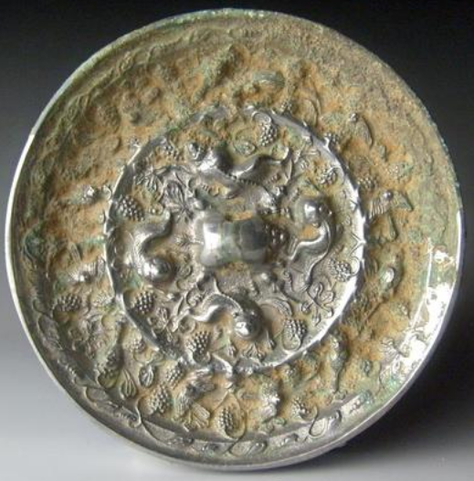

This early Tang Dynasty (618-907 CE) mirror (4.3 in. dia., 405 gm.) is a fine example of the "Lion and Grape" design (otherwise incorrectly called the "sea horse and grape type"). Its silvery appearance is due to the high tin content in the bronze which gives it a lustrous effect. It has a convex reflective face and a reverse side with symbolic motifs in relief.

The central knob is a lion whose arched body forms the loop for the cord handle. About him are four lions reclining on a ground of grape vines with butterflies. This ground is enclosed by a raised rim with sixteen clusters of grapes on its inner side.

In the actual Lion Dance these Lion costumes were wicker structures covered with cloth and enclosed several masqueraders.

In an outer zone are orioles both in flight and perched among hanging clusters of grapes. The border is a thin rim with an inner band of an abstract floral design of budding blossoms.

This "Lion and Grape" mirror served a twofold purpose: to reflect the viewers' earthly visage and to impart a reflection on eternity. The functional reflecting face which would have been painted with mercury to enhance its reflectivity was complemented by a reverse side with symbolic motifs suggesting a cosmic theme to be reflected upon by the viewer (cf. Plumer 1941).

The scheme consists of a motif (the lion) circumscribed by two circles—the axis of the universe surrounded by the bands of heaven. The outer band, indi­cating the rim of the encompassing dome of the sky, completes the cosmic structure.

The vine and grape motif first appeared in Sassanian art, and its use here demonstrates Persian influence (Yetts 1939:161). This reflects the influence of Manichaean ideas from the far western reaches of Central Asia, in the area of present day Xinjiang Uyghur Autonomous Province.

The lion patterns originated in early T'ang times and represent the same idea in sculpture as the "Dance of the Lions of the Five Directions." This, accompanied by the music of "Universal Peace," was a popular musical performance at the Chinese court during the Sui and T'ang Dynasties. The profusion of grapes, symbolic of luxurious eating and drinking may have had a hedonistic significance in keeping with the materialistic outlook of the T'ang court, but intention of these mirrors is to impart joyful exuberance by reflecting on dance, symbolized by lions, and song, symbolized by sweet-singing orioles, of a world finally at peace after four centuries of war and chaos.

In the early twelfth century, Sung antiquarians dated these mirrors in the Han period (202 B.C.E. —220 C.E.), associating them with the famous traveler, Chang Chien. According to tradition, he had in­troduced grapes into China from Xinjiang when he returned from his trip to Bactria in 126 B.C.E. However, most scholars today believe that many "Lion and Grape" mirrors date from the T'ang Dynasty (638-906 C.E.), but they made their first appearance late in the preceding Six Dynasties period since the earliest dated "Lion and Grapes " mirror comes from the early seventh century C.E.

The Persian interlaced motifs and the naturalistic forms skillfully represented in high relief, are characteristic of the art of the T'ang Dynasty.

The graceful geese and the beautifully rendered grapes are quite different from the stylized designs of the Han period. The exu­berance of the over-all pattern suggests a date in the middle T'ang period, the 7th or 8th century.

A lion dance costume is illustrated in the oldest comprehensive treatise on Chinese music, the Yue shū樂書 "Music Books" (Chen: 173, 3b). These 220 juan 卷 (scrolls) were completed in 1101 by Chen, Yang 陳暘, vice-minister of rites, a native of Minqing County, Fujian Province, where he would have experienced the performance of the Lion Dance when he was a jinshi (a palace graduate student), since the dance had been brought to southern China from Xinjiang Province in the Tang dynasty. The description of the Lion dance occurs in the second part that deals with dance, play and the music of the barbarian peoples.

In the eighteenth century the knowledge of the history of the Lion Dance was appreciated in its guise as the iconography behiind the "Lion and Grape" mirrors by Emperor Qianlong (乾隆帝; WG: Ch'ien Lung, 1711 –1799) the sixth emperor of the Manchu-led Qing Dynasty, and the fourth Qing emperor. He listed twenty seven "Lion and Grape" mirrors in the Ming Shou Chien Ku, a description of bronzes in the Imperial Collection (Swallow 1937: 52). Emperor Qianlong was a major patron of the arts and saw himself as an important "preserver and restorer" of Chinese culture by gathering items from China's great private collections and placing them into the imperial collection that had originated in the first century BCE (Holzworth 2005). Qianlong followed the art market in antiquities, using a team of cultural advisers, both elderly Chinese literati and Manchu connoisseurs, who helped find private collections for sale. Sometimes, Qianlong forced wealthy courtiers to forsake art objects he wanted by persuading the current owners that only by placing them within the secure walls of the forbidden City could they save their precious objects from theft or fire (Spence 2004). His massive art collection became an intimate part of his life, and he was particularly interested in collecting ancient bronzes and especially bronze mirrors (Holzworth 2005). He recognized the importance of the "Lion and Grape" mirror for he knew the particular value of its iconography deriving from the far western reaches of China as indeed he himself was of Manchu ancestry from the far eastern reaches of China.

References:

Holzworth, Gerald. 2005. "China: the Three Emperors 1662–1795". The Royal Academy of Arts. 12 November. http://www.threeemperors.org.uk/index.php?pid=19.

Cammann, S. 1953. The Lion and Grape Patterns of Chinese Bronze Mirrors, *Artibus Asiae*, XVI: 272ff.

Chen, Yang. 樂書 *Yue Shu*; 陳氏樂書 *Chen Shi Yue Shu*   
 The full text is most easily found in the文淵閣四庫全書 Wenyuange Siku Quanshu (Index plus 1500 volumes), 經 Jing, vols. 211-220 (禮 rites followed by 樂 music). This edition includes a contents list with each folio, but no general table of contents. Another edition is Yue shu : er bai juan / [Chen Yang zhuan]. 樂書 : 二百卷 / [陳暘撰]. Edition : Di 1 ban. 第1版. Published : Beijing : Beijing tu shu guan chu ban she, 2004. 北京 : 北京圖書館出版社, 2004. 40 vols. (ISBN: 9787501325290 ).

Plumer, J. M. . 1941. *Design and Technique in Ancient Chinese Bronze Mirrors*. Ann Arbor.

Spence, Jonathan. 2003/2004. Portrait of an Emperor, Qianlong: Ruler, Connoisseur, Scholar, *ICON Magazine* (WMF (World Monuments Fund): retrieved 12 July 2011

Swallow, R. W. 1937. *Ancient Bronze Chinese Mirrors*. Beijing.

Thompson, Nancy. 1967. The Evolution of the T'ang Lion and Grapevine Mirror, *Artibus Asiae* 29(1): 25-54

Yetts, W. P. 1939. *The Cull Chinese Bronzes*. London, 1939.

Zhao Hankun 趙含坤. 2005. *Zhongguo leishu* 中國類書. Shijiazhuang: Hebei renmin chubanshe, p. 92.

